<https://www.surfsession.com/articles/les-surfeurs/hommage-jacky-rott-pionnier-surf-francais-608195946.html>

**Please visit the link above to read the testimonial article. It is shown in MS Word below in the event links change or are deleted. English translation by Google Translate.**

TRIBUTE TO JACKY ROTT, PIONEER OF FRENCH SURFING.

THE SURFERS – Passed away at 87, the Tonton Surfer was the first to try surfing in 1952.

By Olivier Servaire - @surfsessionmag - Saturday June 8, 2019 at 12:55 p.m.

Photos D.R. et Gibus de Soultrait

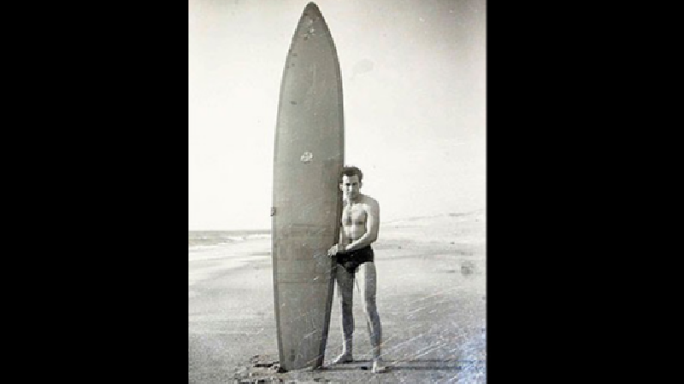

With the death of Jacky Rott, all French surfers have lost an uncle!

Not only because he was the first to attempt to slide upright on the waves of Anglet and Biarritz in 1952, but also because he made the first shapes in France.

If this first attempt took place on an improvised board after seeing a film at the cinema, his following achievements made it possible to equip the first wave of French surfers in the 60s.

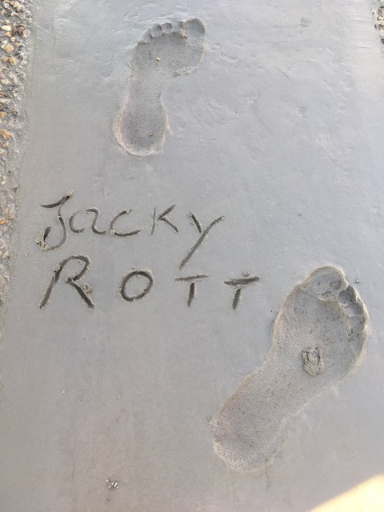

This discreet man is already hailed by the surfing community. Here is the tribute of Gibus de Soultrait, co-founder of Surf Session:

“Jacky Rott, who was the first French surfer (with his famous attempt in 1952) and one of the bravest of the band of Tontons Surfers who started surfing in the summer of 1957, has passed away.

Jacky Rott immediately began to build boards at his home in Dax based on the board imported from Peter Viertel. Then he teamed up with Michel Barland and the two friends founded Barland/Rott Surfboards which were the boards of the majority of surfers in the 60's.

Jacky represented France with his friend Jo Moraiz at the World Championships in Peru in 1962, the occasion of an epic journey for the two friends.

Passionate, Jacky surfed all his life, as much as his courage and his body allowed him.

For several years he had been fighting cancer, resisting suffering so as not to let go of the loved ones around him and for whom he was dear.

Summer 2018, the city of Anglet honored him with the imprint of its feet in the Avenue du surf, during a moving and friendly ceremony, surrounded by Maritxu Darrigrand, Pauline Ado, Joël de Rosnay, Nat Young, Tom Curren

With Jacky Rott gone in his 87th year, it is this "comradeship" of surfing, with a strong character, dear to this era of Tontons Surfers that is leaving. But let's keep in the water the humor that also characterized it.

Farewell Jacky”

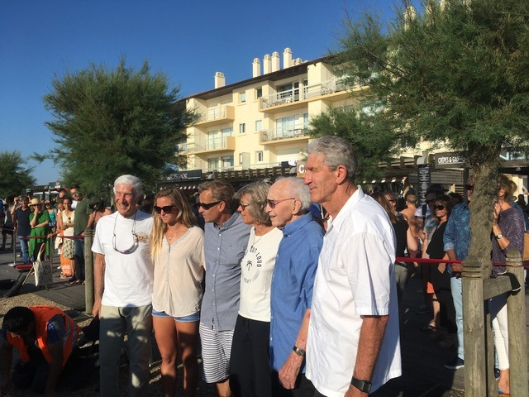

The journalist Alain Gardinier, who baptized the uncle surfers and retraced their journey in a reference book, also pays tribute to the pioneer of pioneers. He recalls how Jacky Rott ventured into the creation of plastic-covered balsa boards in 1957, before launching his Neptune label.

I've personally been lucky enough to find a perennial nickname for the surf clevers in France. From now on, Pierre Laharrague, Michel Barland, André Plumcocq, Bruno Reinhardt, Jean Brana, Jo Moraïz or Joël de Rosnay are for all "surfer uncles". However, there was a pioneer of pioneers among them. Back in 1952, while watching the Biarritz Coliseum in the cinema for a news series devoted to the reconstruction of Pearl Harbor in Hawaii, the ebonyist Dax discovered surfing. In the space of seconds, this wave freak spotted guys standing on tall wooden boards. As he explains: "Here in Biarritz, we did plankys lying down and we never thought that one day we'd stand up on a plank." Without any technical data, it is the shape of a planky, this small curved wooden board, which takes the first prototype made by Jacky Rott and his brother in their Dax workshop. The board is hollow, formed of white wooden beams covered with resin coated fabric then varnished. In short, unsurfable, especially since Jacky couldn't know that under a surfboard we found a fin. Yet Jacky will try it on an early July 1952 morning on the beach of the Chambre d’amour in Anglet. The attempt will not be conclusive, no more than the one made in the afternoon at Ilbarritz beach. Then our hero despite him will go to perform his two years of military service which will be followed by another two years in Algeria, obligatory war. When, in early 1957, he returned to the country, he was told by his friend George Hennebutte that the previous summer, an American named Peter Viertel had come to the beach of the Basque Coast with a real surfboard. Plus she stayed there for the winter. Jacky immediately picks up the ribs and starts making two balsa boards that he covers in plastic to make them waterproof. In the summer of 1957, he will be one of the most diligent to tame surfing and will succeed so well that he will become our first real champion, as well as the first French manufacturer with Netpune boards. More than an uncle, a unique and charismatic, kind, humble and so friendly character has just left us. Surfing in France and Europe will never be the same without Uncle Jacky.

<https://www.facebook.com/alain.gardinier/posts/10157562325184236>

[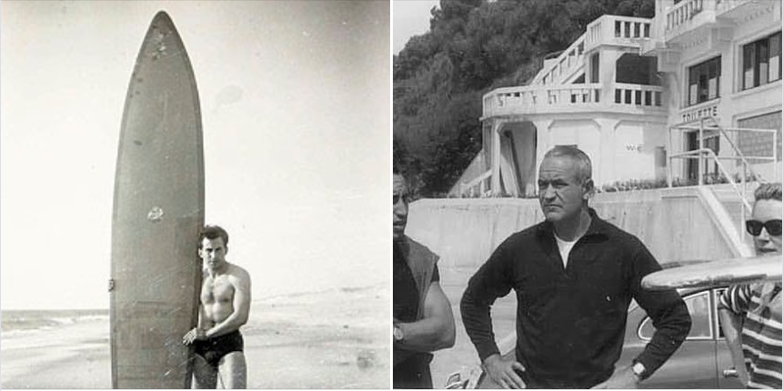](https://www.facebook.com/photo/?fbid=10157562323859236&set=pcb.10157562325184236&__cft__%5b0%5d=AZUs5xWhBXF1khHahN2mHOaiRkF7JL2xj-dKcseIAgpwsxSYl_BLHMe-mg2_bpqD7NuhnmrVO1be6-XEJ5iITOP-rVq71E4HJp_IdUNDapITyx6wefUoYZVFLm3iovUczCw&__tn__=*bH-R)