<https://www.sudouest.fr/pyrenees-atlantiques/anglet/landes-pays-basque-deces-de-jacky-rott-premier-surfeur-francais-2583019.php>

**Please visit the link above to read the testimonial article. It is shown in MS Word below in the event links change or are deleted. English translation by Google Translate.**

# Landes/Basque country: Death of Jacky Rott, the first French surfer

By Emma Saint Genez

**First Frenchman to climb on a surfboard, Jacky Rott, a native of Dax, died Friday June 7, 2019 at the age of 87**

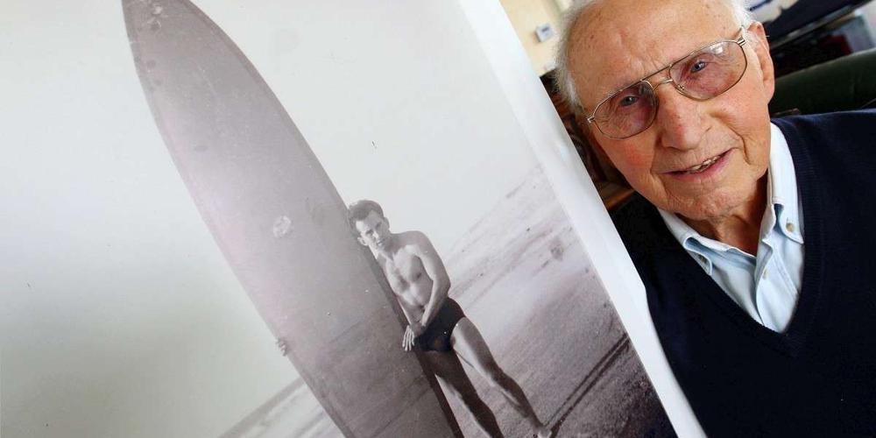

Jacky Rott was born in Dax and spent a good part of his life in the waves of Hossegor, Anglet and Biarritz. A cabinetmaker by profession, he was 21 when he discovered, on the newsreel screened in the cinema, an American soldier riding down a wave standing on a board. "I was stuck! I don't remember what movie I went to see that day but I never forgot those few seconds", reports the site of the French surfing federation which pays tribute to the uncle surfer on its website [https://www.surfingfrance.com](https://www.surfingfrance.com/disciplines/surf/jacky-rott-nous-a-quittes.html).

The Dax cabinetmaker then tried to make his own board, out of bald cypress wood. He tested it in July 1952 in Anglet and Ilbarritz. The result is not conclusive: the board slips under his feet like a piece of soap, and breaks on the rocks while he has to swim back to the sand.

It will be necessary to wait for the Californian Peter Viertel to pass through Biarritz in September 1956 and leave his board to be repaired by George Hennebutte, future inventor of the leash (the link that keeps the surfer to his board). Returning from the Algerian war, Jacky Rott made two copies to the same dimensions as the board entrusted by the American to his Basque craftsman friend, and coated them with paraffin.

In the spring of 1957, the Dax cabinetmaker renewed his attempts in the waves of Hossegor. This time, he manages to stand up on the board which he leads to the shore. In its wake was born the first generation of French surfers.

In 1959, Jacky Rott founded the Waikiki surf club with his friends Georges Hennebutte, Joël de Rosnay and Michel Barland. With the latter, he designed and manufactured the boards of most surfers of the 1960s. In 1961, ten years after his discovery in the cinema, the man from Dax won the French surfing championship. In 1962, he took part in the world championships in Peru.

**Funeral Tuesday**

Jacky Rott has not surfed since he was 75 and had been battling cancer for several years. But this pioneer remains a legend in the middle of surfing. Last summer, on July 10, 2018, he launched his footprint on Anglet surf avenue alongside those of champions Maritxu Darrigrand, Pauline

The funeral of Jacky Rott will be celebrated on Tuesday June 11 at 4 p.m. in the Notre-Dame-de-Buglose basilica in Saint-Vincent-de-Paul (40), before his burial in Dax.