<https://www.surfingfrance.com/disciplines/surf/jacky-rott-nous-a-quittes.html>

**Please visit the link above to read the testimonial article. It is shown in MS Word below in the event links change or are deleted. English translation by Google Translate.**

**Jacky Rott, pioneer of French surfing, died on Friday June 7 at the age of 87 following a long illness.**

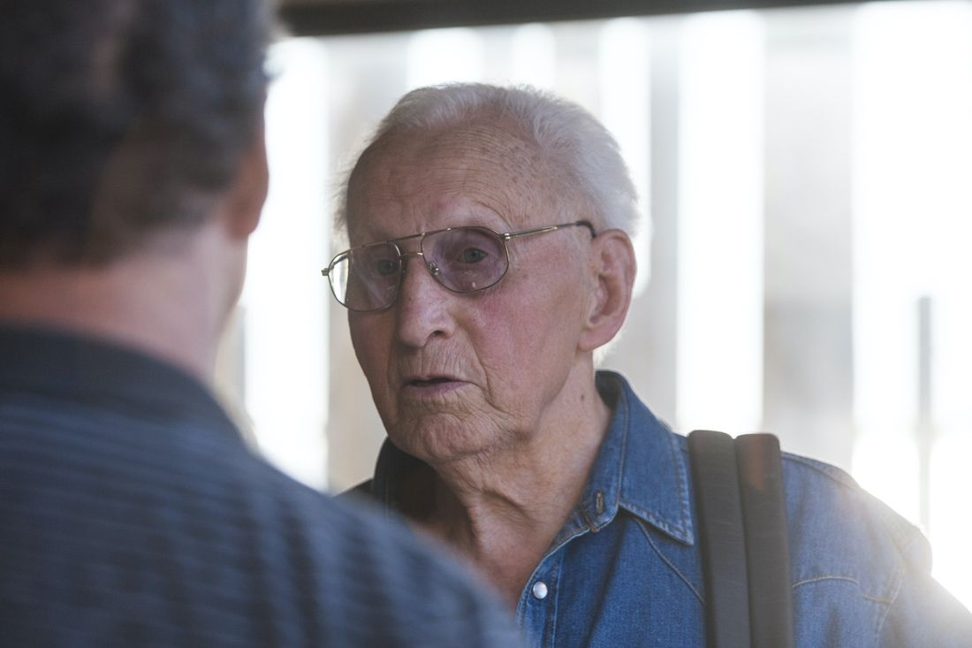

A religious ceremony will take place in Dax in the coming days. A traditional ocean ceremony for surfers, open to all, should take place on Sunday June 16 in Parlementia (Bidart-Guéthary) at the end of the morning (to be confirmed depending on the weather).

|  |  |  |
| --- | --- | --- |
| sl82 11br |  | Jacky Rott was the pioneer of surfing pioneers in France. The first French surfer to stand up on a surfboard in 1957. Jacky Rott was born in Dax in 1932. Cabinetmaker in the family business after the Second World War, he regularly goes to the ocean where he practice like so many other young people the planky: take waves lying on a curved wooden board. His life changes in a movie theater in 1951. On the newsreels that precede the film at the time, he watches a report on the 10th anniversary of the attack on Pearl Harbor in Hawaii. “We saw American soldiers indulging in their favorite sports, he explained to a journalist ten years ago. Some played basketball, others tennis or American football. And then suddenly, we saw one of them riding down a wave standing on a board. I got stuck! I don't remember what movie I went to see that day, but I never forgot those few seconds”. |

**A first attempt in… 1952**

He now has only one idea: to make a board so he can also take standing waves. His first attempt looks like a very large, very smooth solid wood ski. His first attempt, in July 1952 in Anglet then in Ilbarritz, ended in bitter failure: on several occasions, the board slipped under his body and spun without him, finally ending its course in the rocks where it broke in half.

Military service in Toulon in 1953 then the Algerian War took him away from the ocean and surfing. He returned home in the winter of 1956. A few months earlier, Peter Viertel and Dick Zanuck, two Californians passing through Biarritz for the filming of the film "The Sun Also Rises", based on Ernest Hemingway's novel, had tried surfing at the Côte des Basques. Viertel, who dinged his board, left it to be repaired by Georges Hennebutte, a local craftsman and future inventor of the leash. This allows Rott to measure the sides of the board. Who makes two and, above all, coats them this time with paraffin on the good advice of an acquaintance.

**He secretly tries his board at Hossegor**

In the spring of 1957, at the old northern groyne in Hossegor, Jacky Rott got into the water discreetly under the watchful eyes of his father, mother and brother. From his first try, he stands up and rides the wave to the shore. On the strength of his success, he left to surf in Biarritz a few days later, and took with him a whole generation of surfers.

The following ? Jacky Rott and his friends Georges Hennebutte, Joël de Rosnay and Michel Barland founded the Waikiki surf club in 1959; he won the French surfing championship in 1961 then the first European championship the same year; he participated in the 1962 world championships in Peru; he partners with Michel Barland for the manufacture of the French Barland/Rott Surfboards surfboards. And above all, he never stops surfing.

In the summer of 2018, the city of Anglet honored him with the imprint of his feet in the Avenue du surf, during a moving and friendly ceremony. It will slide on the waves for a long time before dying out, carried away by illness on the night of June 6 to 7, 2019.

The French Surfing Federation sends its most sincere condolences to his family. Happy surfing up there Jacky

**Alain Gardiner :**

“I was personally lucky to find a lasting nickname for the pioneers of surfing in France. By now Pierre Laharrague, Michel Barland, André Plumcocq, Bruno Reinhardt, Jean Brana, Jo Moraïz or Joël de Rosnay are all “uncle surfers”. However, there was among them a pioneer of pioneers. (…) During the summer of 1957, he will be one of the most diligent in wanting to tame surfing and he will succeed so well that he will become our first real champion, as well as the very first French manufacturer with his brand of Neptune boards. More than an uncle: a unique and charismatic character, kind, humble and so sympathetic who has just left us. Without uncle Jacky, surfing in France and Europe will never be the same again”.

**Jean Louis Bianco:**

“RIP Jacky! Legend among Legends in France and more than in France! My first boards! I had the chance to meet Jacky Rott several times in Hossegor and Biarritz. How sad even if it was expected. The French Surfing Federation and surfing in France owe you a lot, well beyond your boards with Michel Barland. Rest in peace. Condolences to your family’.

|  |  |  |
| --- | --- | --- |
| 7637831420 6d369b0422 z |  | Jacky Rott (au centre) avec les Tontons surfeurs en 1959 à la Côte des Basques. (Photo Joël de Rosnay) |